**Life of Themistocles**

Themistocles was a general and politician of Athens, Greece in the late 6th and early 5th centuries BC, and was elected as archon in 493BC. He played a pivotal part in ensuring Greek victory in the first and second Persian invasions (490BC, 480-479BC), and most notably persuaded the Athenians to advance their naval forces in this time through the commissioning of two-hundred triremes in 483BC.

In 471-470BC, he was ostracised (expelled) from Athens and went into exile, where he eventually settled in Asia Minor and served under the Persian King Artaxerxes I. In recognition of his service, Themistocles was gifted the sovereignty of the city of Magnesia (also known as Magnesia on the Maeander), where he settled and governed until his death in 459BC.

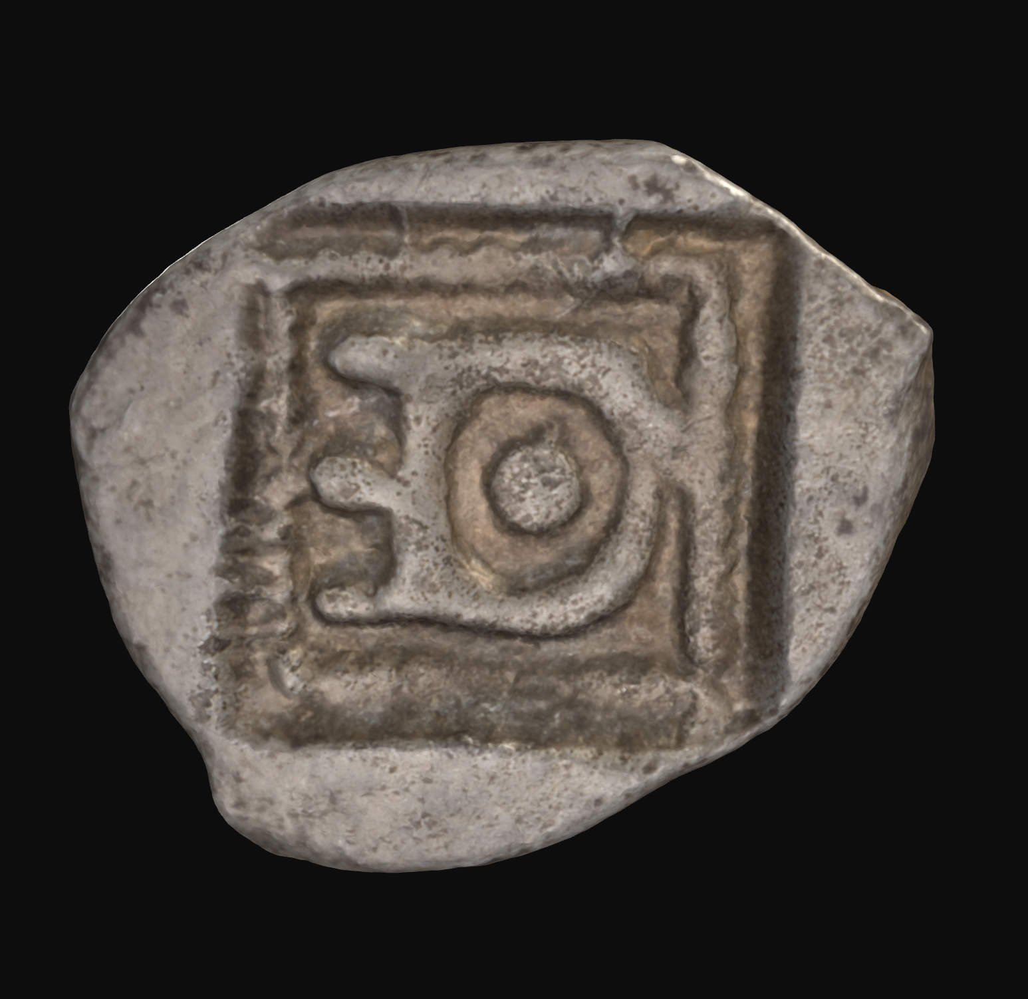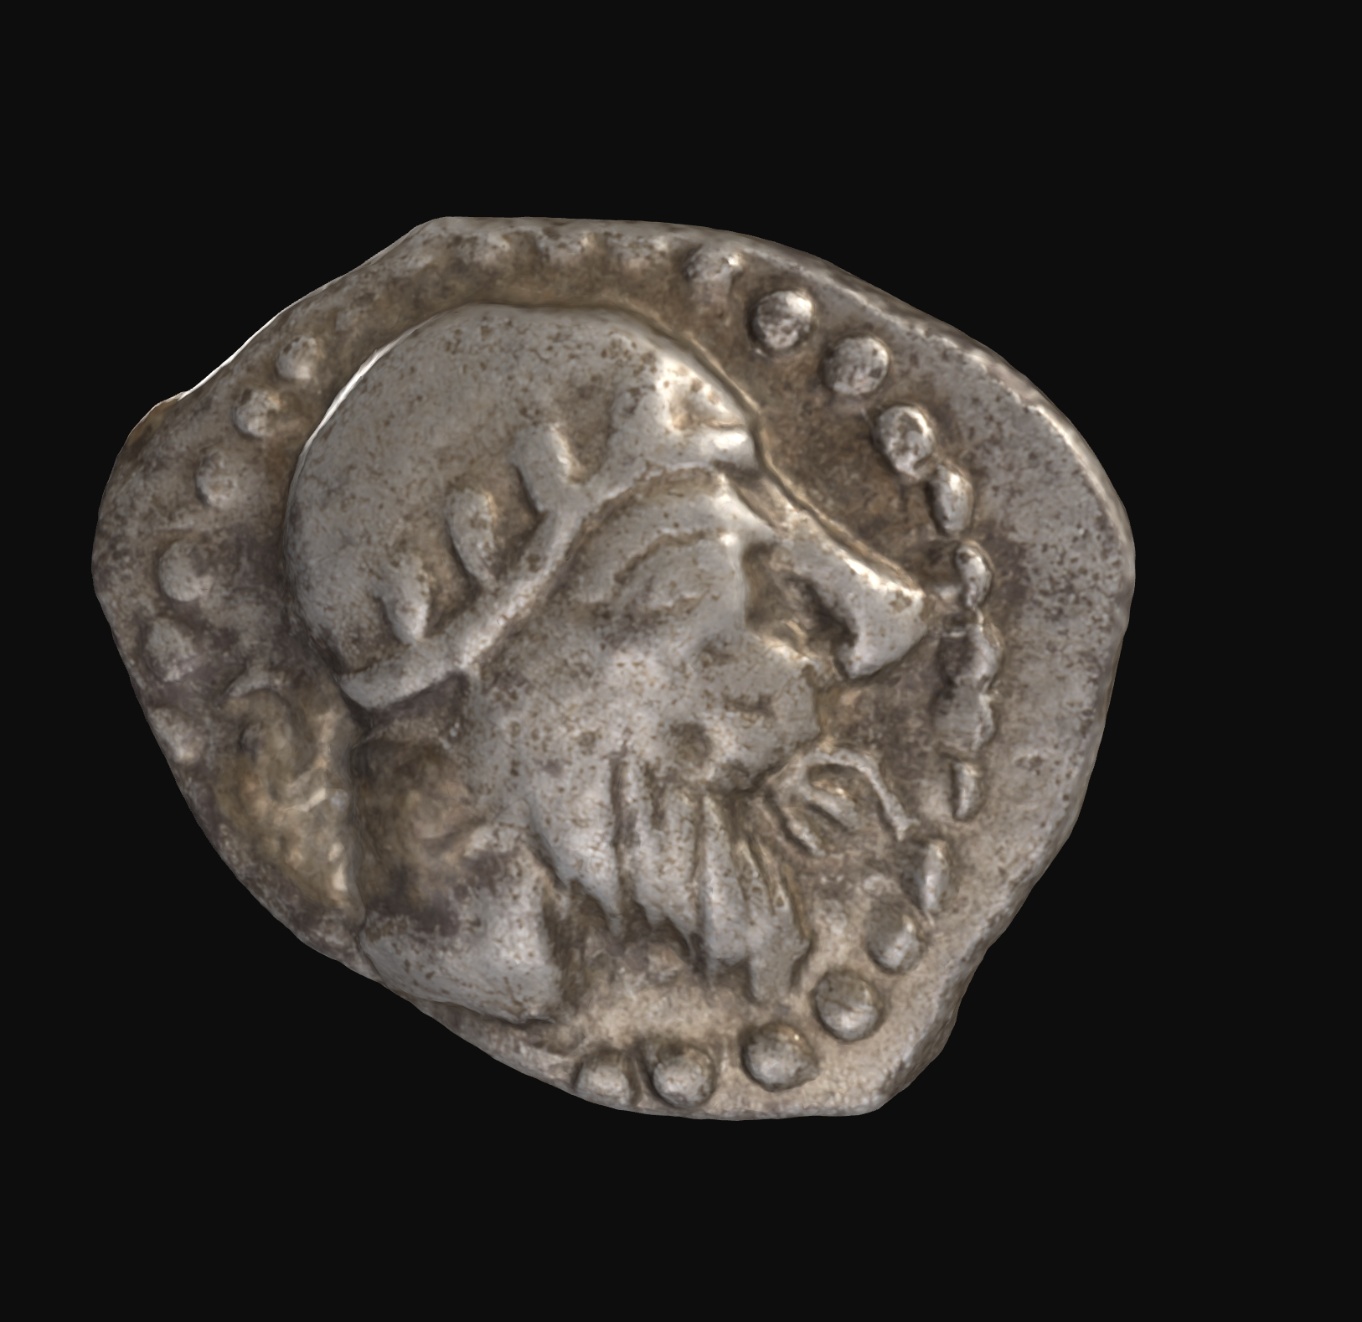

*Bronze Hemiobol, minted in Magnesia ad Maeandrum, Ionia between 465 and 459BC. Obverse depicts the head of the Olympian deity Hephaestus, bearded and wearing a laureate pilos. Reverse depicts a dotted square border within an incuse square, with the monogram ‘ΘE’ or ‘TH-E’ symbolic of the coin’s issuer; ‘Themistocles’.*

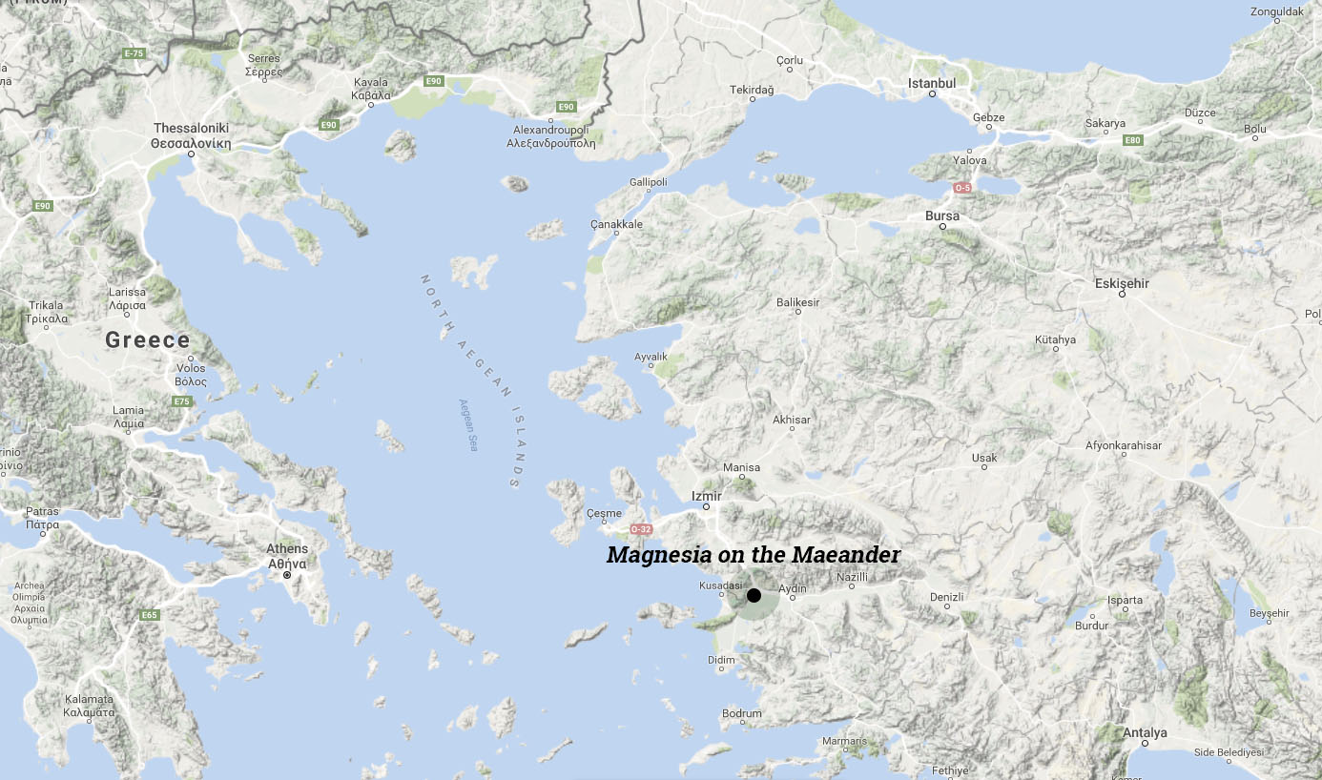

*Location of Magnesia ad Maeandrum, Ionia in relation to Greece.*

Image Source: <https://proceduralmagnesia.com/magnesia-through-time.html>

**Establishing Greek Culture in Persia**

As part of his effort to reestablish the cults of several Greek deities in Magnesia and thus promote Greek character to his city, Themistocles depicted several gods and goddesses on his coinage. Examples of these include: Apollo, Artemis, Athena, Zeus and Hephaestus.

**Laureate Pilos Meaning and Significance**

Over recent decades, there has been ample debate as to the meaning and significance of the laureate pilos depicted on Hephaestus’ head. One theory is that the headgear originates from a particular myth surrounding Hephaestus in Greek Mythology.

According to the myth, Hephaestus was thrown from Olympus by his mother Hera, who was horrified by his ugly appearance after his birth. Later, when Hephaestus was grown, he took revenge on his mother by crafting an elaborate gilded throne. Once she sat on it, she could not get up. Despite his mother’s appeal for mercy, Hephaestus refused to free her, so at a Symposium (drinking party for aristocratic males), the god Dionysus kept the wine flowing and in turn, ensured Hephaestus was inebriated. He then brought him back with him to Olympus on horseback, and adorned atop Hephaestus’ head, was the laureate pilos that he obtained from the party.

This became such a well-known myth surrounding the deity in the ancient world that Hephaestus was frequently depicted wearing the laureate pilos, even when working in the forge.

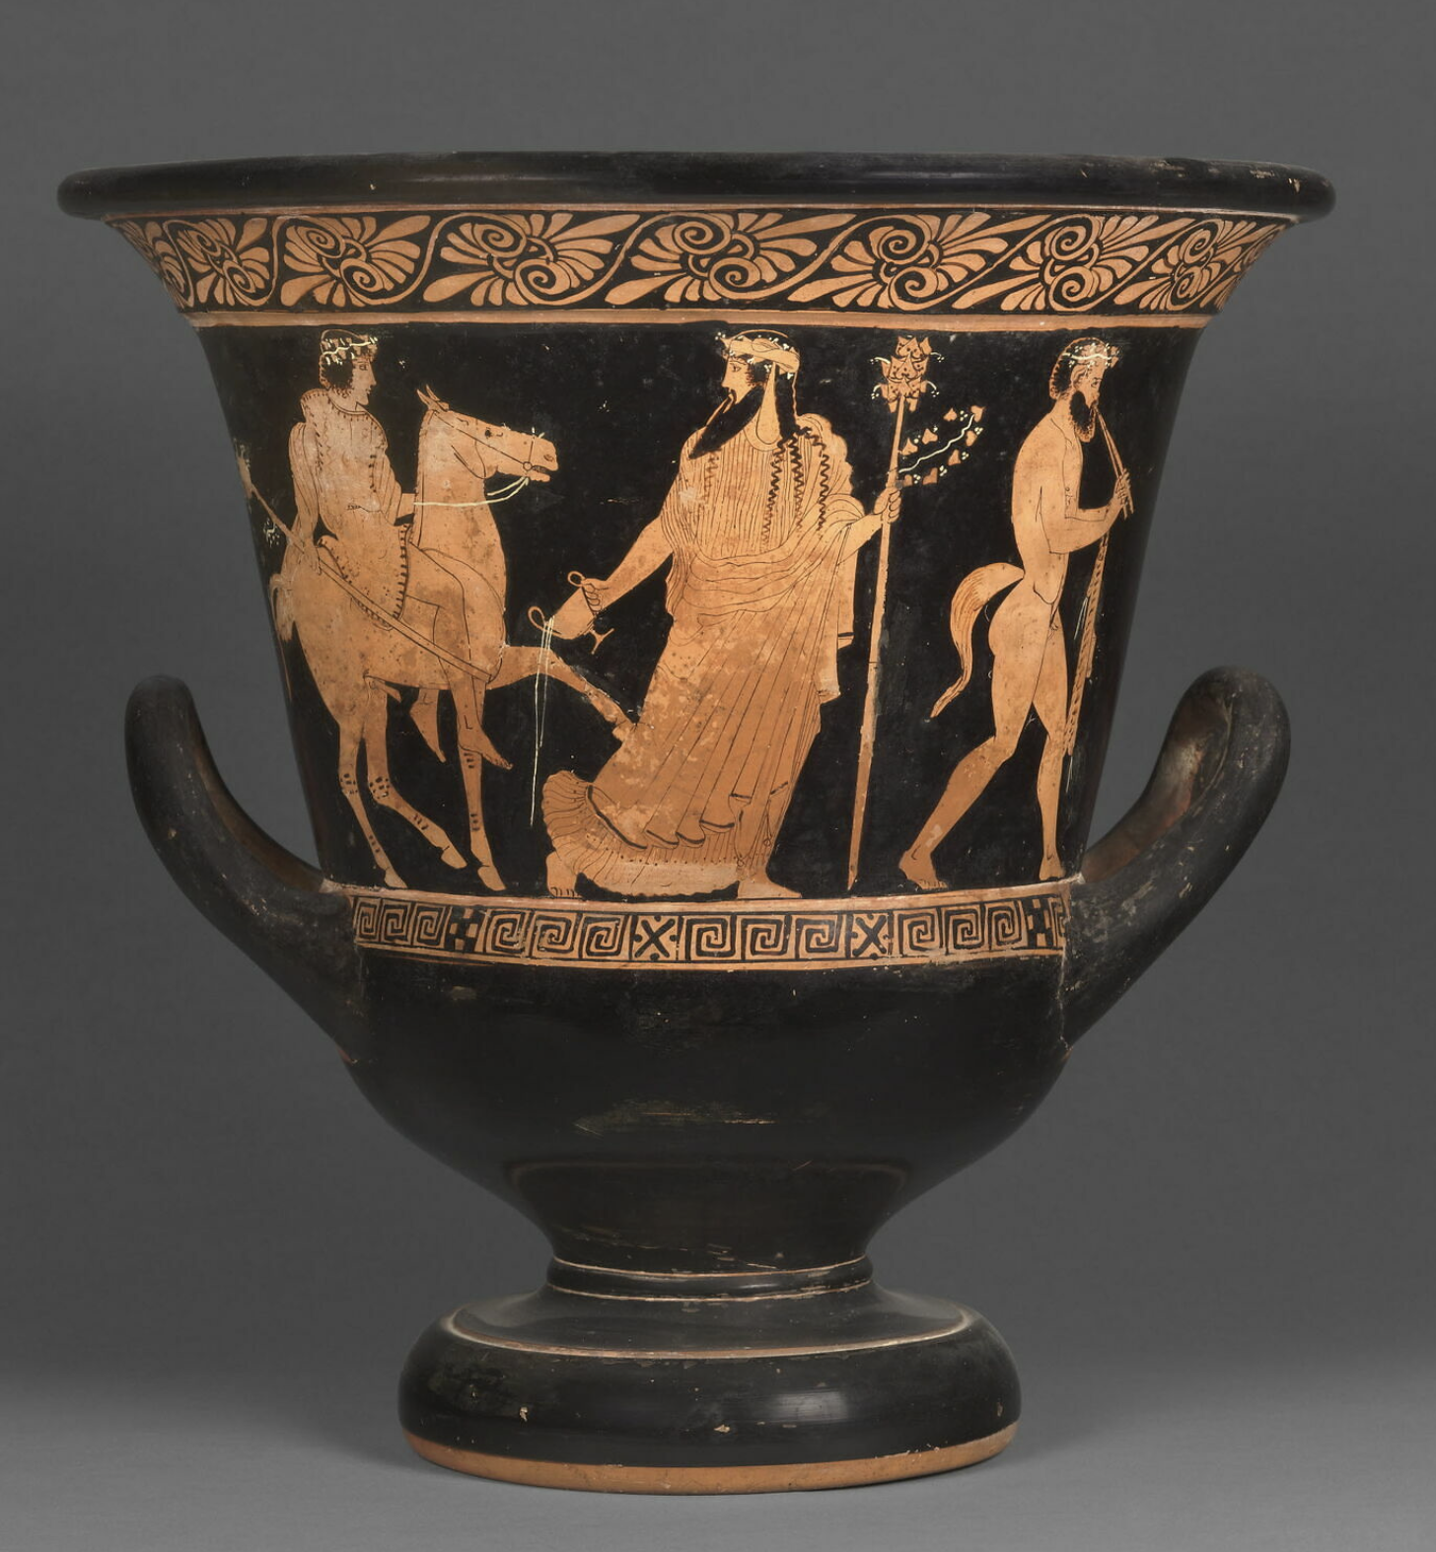

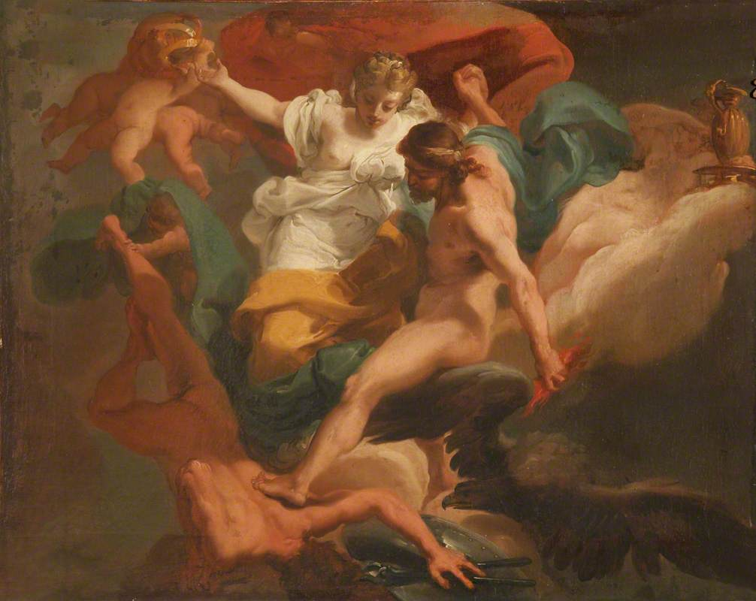This scene was depicted on several vases from the 6th and 5th centuries BC, as depicted on the right.

*Red-Figure Athenian Krater, 450-440BC. Attributed to the Christie’s Painter.*

*Depicts Hephaestus being led by Dionysus on a horse back to Olympus. Adorned on his head is a laureate pilos.*

Louvre Museum. Inventory Number: N3382. <https://collections.louvre.fr/en/ark:/53355/cl010270256>

*Zeus with Hera Expelling Hephaestus from Olympus*

*Oil on Canvas by Ubaldo Gandolfi (c.1770AD)*

National Trust, Osterley Park. Accession Number: 772288. <https://artuk.org/discover/artworks/zeus-with-hera-expelling-hephaestus-220715>